- Under Visualise_funding tracking “ Clinical research visualisation”

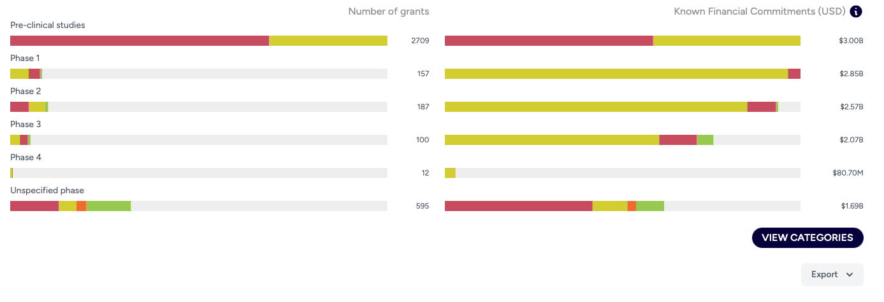
Text and mapping changes in visualisation
Preclinical studies - No change
Phase 1 - Phase 1/ Early Stage
Phase 2 - Phase 2/ Intermediate Phase
Phase 3 – Phase 3/ Late Stage
Phase 4 – Phase 4/Post-Market
Unspecified phase/ Stage

Others:
Add text in red -
Use the ‘view categories’ to explore clinical trial phases/ development stages in more detail by intervention focus

Remove text in red -
Note that some clinical research may fall under multiple categories; although, these overlaps are not explicitly shown. For example, phases are displayed with “clinical characterisation” awards where they co-occurred with other interventions. For diagnostic trials, preclinical studies are not included in the data presented. The diagnostics visualisation will soon be updated with a revised classification of diagnostic research awards to better reflect the scope of funded awards.

Under ‘view categories’

Mapping changes_Only update the logic for diagnostics

Remap using
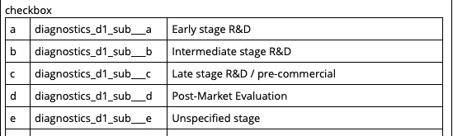
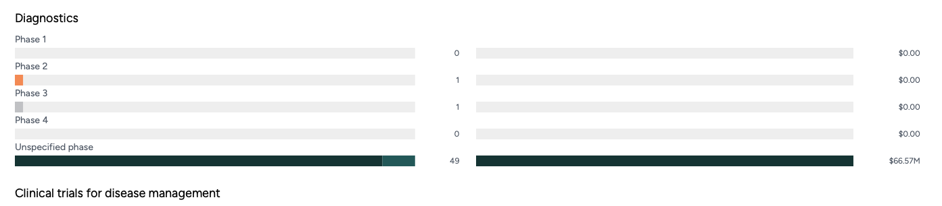

- Under Visualise_ Policy Roadmaps_100 Days Mission

Change text on jump card to Research and Policy Roadmaps
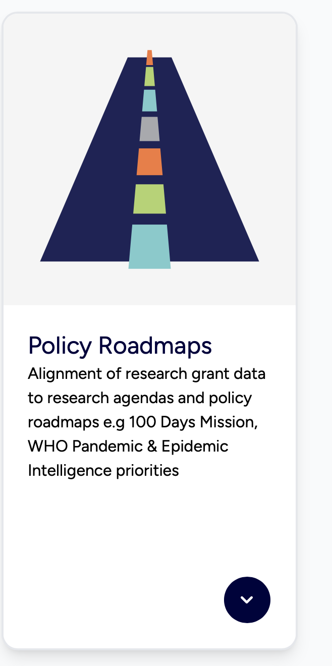

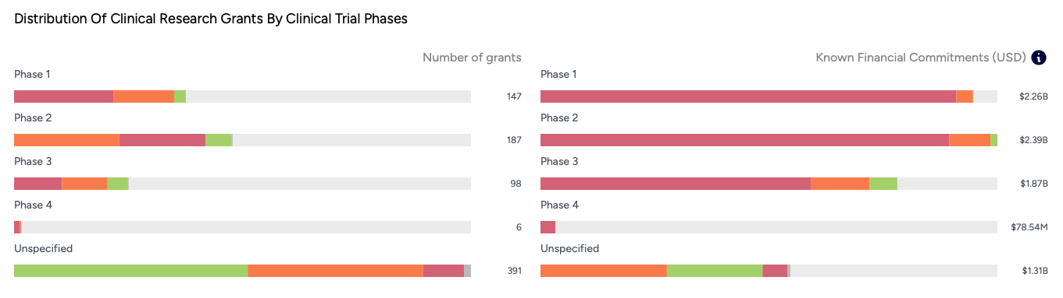
Phase 1 - Phase 1/ Early Stage
Phase 2 - Phase 2/ Intermediate Phase
Phase 3 – Phase 3/ Late Stage
Phase 4 – Phase 4/Post-Market
Unspecified phase/ Stage

Under ‘view research areas’

Mapping changes_Only update the logic for diagnostics
Remap using


